**Change Istio Components Quota**

* Log in to master-1 of the cluster for which you want to increase the quota of istio components.
* Do **ll | grep istio** andlook for below highlighted file

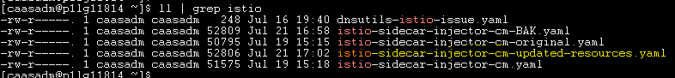

* Take a backup of the file before editing it

**cp istio-sidecar-injector-cm-updated-resources.yaml <newFileName>.yaml**

* Edit the new file created

**vi <newFileName>.yaml**

* At the beginning of the file look for below conf (line number 18)

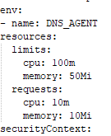

Change the resources.limits.cpu and resources.limits.memory of **istioinit-cleaniptabels** to a relatively higher value as per the situations ask.

* Towards the end of the file (line number 569), look for below conf and change the resources.limits.cpu and resources.limits.memory of **proxy** and **proxy_init** to a relatively higher value as per the situations ask

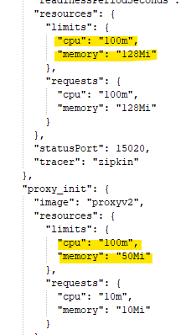

* Save the file after the above changes are done
* Deploy the changes

**kubectl apply -f <newFileName>.yaml -n istio-system**

* Check if the changes applied are reflecting or not

**kubectl describe cm istio-sidecar-injector -n istio-system**

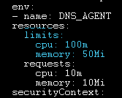

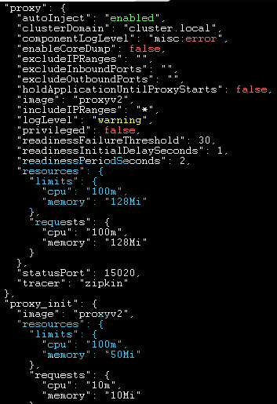

* Ask the application teams to scale their pods down and then up for the changes to reflect.